Common Tickets
Deployment request:

- Separate document available for Deployment request.

Disk space Checking:

- We have initiate the Disk Space monitoring scripts in all the servers it will intiate and send mail at every 2 hrs.
- We have monitoring and clear the spaces.

DB Maintenance:

- Confirm the production team
- Check the dashboard status
- Rename the index.php file
- Stop the cron service (service crond stop) or (/ete/init.d/crond stop) multi project server means cmnd the particlualr project scripts
- Check the running scripts (ps -ef |grep perl)
- Wait 2 min still scripts are running means Kill the scripts (kill -9 ID)
- Take the mysql dumb in space available path (mysqldump --routines -u root -p mydatabase > mydatabase_`date -I`.sql)
- Check the space and compare live DB and backup DB file seize
- Run the DB maintenance scripts
- Compare the batch ID of live and archive DB (coc_file info.table)
- Optimize all the tables
- Start cron service (service crond start) or (/ete/init.d/crond start) multi project server means uncmnd the scripts
- Check the scripts are running or not (ps -ef |grep perl)
- Rename the index.php file
- Send mail to production Team.

Slowness Issues:

- We have lo-gin the server and check the load on TOP cmnt and IO for iostat -x 2 cmnt and check the query running or not in the mysql
- Login mysql through the cmnt - mysql -u root -p
- passwd
- show processlist;
- Any query running lot of time kill the query with DEV team confirmation.
- If any problem in server load check which process will take too much load, if mysql means restart the mysql service with the prior infomation pass to DEV & PRODU team.
- Everything optimal means send mail to production team.

Code update:

I. Code update Request in SVN
- Dev team send request mail like below format
- Once received mail we will start code update.
- Open the requested location (server) in live or staging.
- Go to the file path and folder path (coc_precieirish/controller)
- svn update (Fle Name)
- After that it show like Update Revision means code updated At Revision means code not updated.
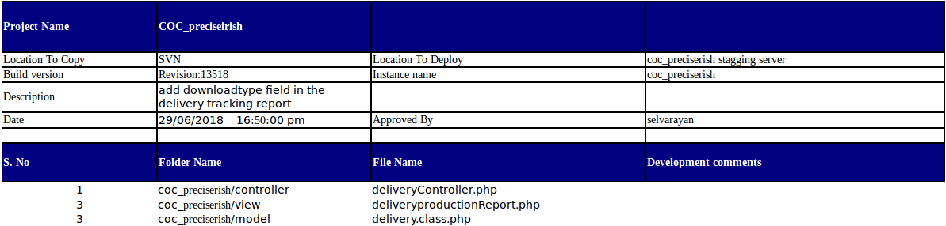

II. Code update Request in GIT
- Dev team send request mail like below format
- Once received mail we will start code update.
- Open the requested location (server) in live or staging.
- Go to git user (su git)
- Go to the script path or php path (coc_pad/scripts) (coc_pad/webfiles)
- git pull
- After that it show some like cmnt “commit your local changes and script path”
- git commit -m 'local changes' script path and file
- Then again git pull
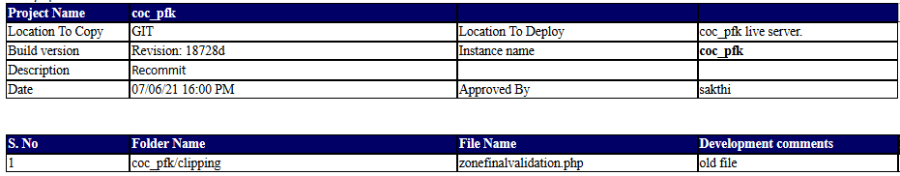

Remove files from server:
- Support team forward the production team mail for us and remove files request.
- Cross check the mail and go to the workfiles path for the requested project and remove the requested batch or files.

Take files backup from server:
- Production team will send mail like “move the attached batches to backup path” so we will check the backup path is there or not if there means move the batches to backup path if not there any backup path means create backup folder and move the files to there.

NLN PPA Text Overlap:

- First go to the path mentioned in mail.
- NLN -2 SERVER (58.68.110.52)
- cd /stglun2-prod/nln_inventory/files/ScanningInput/PPAClarification/filename
- Check the file name format because sometimes input path file name and replacing files name was differ then run the below script in the above selected folder.
- Perl /home/systems/img_resize/resize_image.pl $PWD
- Then copy the files
- cp * /NLN2-data/nln_service1/files/input/filename
- cp * /stglun1-prod/nln_service1/files/input/filename
- If stglun1 partion, file was not available check below partions its available or not.
/stglun1-prod
/stglun2-prod
/stglun3-prod
/stglun4-prod
/stglun5-prod
/stglun6-prod
/stglun7-prod
- Some times they send replace the pages for issue settings process. So we have additionally replace the files on the below path also.
- /NLN2-data/nln_service1/files/workfiles/filename/foldername
- Send mail to production team

Workfile Restore:

- Production team send mail and mentioned the path like Path: /andp/SDLT/Restore/26-03-2018/*.* this.
- We have go to the path and copy the files and paste to workfile location.

Particular Script Not working:

Ex: Imageconvertion , Upload , download , rfs &extraction Script not working means.

- Check the cron log for the particular script.
- Check the script running time. (ps -ef | grep perl) It will vary means kill the script and check the cron log.
- In the cron log shows like no files process not available means communicate support team.

Workspace Connectivity:

- Gorkana workspace connectivity check with customer end.
- Cision Canada , Prcise , Irish & LFMI check our side AWS account.

Module Installations:
- Separate document available for Installation request.
Publication Locked at More times:

Request from Support or Production team regarding RFS-Title/ RFS-Article of KMS Server is locked for more than 20 to 30 minutes. This document defines the process of handling RFS Title and RFS Article issue.

- Steps to be followed if RFS-Title/Article is locked for long time

  - RFS-Title/Article ( issue locked but not transferred/moved to shipment for a long time)

Note: Get information from Production Team about TAT and for how long the request has not been transferred / moved.

- Login to KMS Server
- Run the command given below to go to devteam corntab
crontab -l -u devteam
- Check the log status
For RFS-title:
tail -f /data1/coc_kms/scripts/logs/title_shipment_`date -I`.log
For RFS-Article:
tail -f /data1/coc_kms/scripts/logs/article_shipment_`date -I`.log
If its shows error message as “FTP failed”, then check the connectivity from KMS server to AWS london FTP server.
Otherwise go to Step 4.
- Search the publication id which is not transferred/moved
For RFS-title:
vim /data1/coc_kms/scripts/logs/title_shipment_`date -I`.log
For RFS-Article:
vim /data1/coc_kms/scripts/logs/article_shipment_`date -I`.log.
- Find the Started time of publication from the log
For Example: Started: 93 - 20170706-02-37-04
Find the file size from the log. Path is mentioned in log as “Input zip”.
- Search the publication id which is not transferred/moved
For RFS-Title:
vim /data1/coc_kms/scripts/logs/title_shipment_`date -I`.log
For RFS-Article:
vim /data1/coc_kms/scripts/logs/article_shipment_`date -I`.log
- Check the destination file size
- Login to AWS-London Server and go to below mentioned path
cd /coc_kmspain/files/output/
- Find the file size of publication.zip.temp file as checked in KMS server
- Check repeatedly if the file size does not exceed destination location in more than a minute. If yes, then reinitiate the file.
- If the file is moving at a slow speed then check the bandwidth and TAT from the production team.

- To reinitiate, kill the script which is currently transferring that particular file using below command.
To Kill the script:
ps -ef | grep publicationid
- Immediately inform the support team to backpush that particular publication
- Check again, if the publication is getting transferred or not and follow Step-3 & Step-4
- Once its moved to be shipped, inform the production team

OPOINT RFS ISSUE:

Request getting from support or Production team regarding the RFS issue in opoint .

step1 : login in to the server and go to the crontab by using “crontab -l” and kindly check the shipment script log by using command

tail -f /data/coc/coc_opoint/scripts/logs/`date -I`-shipment_v1.log

Step2 : Find if is there any error in the cron log for eg: overlap lock continuously , and if a files are not moving from normal count in opoint dashboard (RFS process)
go to the crontab by using crontab -e and command the below mentioned script
perl /data/coc/coc_opoint/scripts/shipment/shipment_v1.pl
(Note: if you find the files are locked , ask support team to unlock the files )

Step3: check the script is running by ''ps -ef | grep perl" in the server and kill the script by using the command "kill -9 processID"and Immediately inform the support team to backpush that particular issue

Step4: And now uncommand the script and after a minute check the cron log by using the step1 command Now the files will be moved into next process

KMF Download ISSUE:

Request getting from support or Production team regarding the log download issue in KMF.

step1 : login in to the server and go to the crontab by using “crontab -l” and kindly check the downloader script log by using command
tail -f /data1/coc_kmf/files/logs/`date -I`-download.log 2>&1

Step2 : find if is there any error in the cron log if any thing is there eg: overlap lock
continuously, and if a files are not moving from normal count in KMF dashboard
(extraction process)

Step3 : go to the crontab by using crontab -e and command the below mentioned script
perl /data1/coc_kmf/scripts/downloader.pl
(Note: if you find the files are locked , ask support team to unlock the files )
Step4: check the script is running by ''ps -ef | grep perl" in the server and kill the script by using the command "kill -9 processID"and Immediately inform the support team to backpush that particular issue
Step3: And now uncommand the script and after a minute check the cron log by using the step1 command .Now the files will be moved into next process

